To discuss:
- Mass & losses for fish eggs
- Copepod nauplii – body mass too high?
  - new source https://jeb.biologists.org/content/217/17/3085#ref-3
  - marine copepod varies between 30 and 250 ng C, used mean of 140 converted to g, then converted to fresh mass
  - carbon-to-wet mass conversion factor of 0.05 (Winberg, 1971, Kiørboe, 2013).
- But in any case, missing a density at some sites

Notes on Adirondack Lakes data preparation for fluxing analysis
Darren 10.07.2019

This file documents steps taken to extract plankton and fish densities from the Adirondacks report (Sutherland 1989) and match them to the existing individual body masses associated with the food-web nodes in the GATEWAy database.
It includes details on the potential sources of error.

Lakes
Wolf lake is excluded from flux calculations because pages are missing from the scanned document for this lake (no density information)

Dates
Water physical and chemical measurements, phytoplankton densities and zooplankton densities are for the Summer (July) 1984 measurements presented in the report (used by Havens 1992, 1993). However, fish were sampled at a different time (between 07.05.1984 and 24.10.1984).

Water quality
Temperature is mean water column temperature. Thus, lower temp is mainly reflection of a deeper and thus thermally-stratified lake (see Figure below). We cannot say what temperature the plankton were mainly experiencing from the vertical net tows.
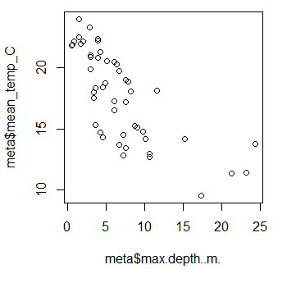

Resource and development nodes
Havens (1992, 1993a,b) added unsampled developmental stages (copepod nauplii, fish fry, fish eggs and detritus) to webs so that taxa has a food source.
Nauplii: At some sites, copepod nauplii were actually sampled, but not at all sites. There are 18 lakes where nauplii were added but there is not a corresponding density record. These are currently excluded from flux calculations, which could leave some consumers resourceless and potentially disconnected.
Fish eggs: There is no density for fish eggs, which are currently excluded. Alternatively, could be given a biomass preference in a similar fashion to detritus?
Fish fry: density was predicted using their mean mass reported in GATEWAY (see section on fish densities below).
Detritus: Note that benthic detritus is only in webs where it has consumers. I set biomass preferences for detritus following the approach/code used by Eion in the workshop – biomass for detritus was set as equal to total of prey plankton biomass for each consumer. The logic is that half the energy is coming from detritus (‘brown’ pathway) and half from the ‘green’ pathway.

‘Dangling’ species
Havens (1992, 1993a,b) describes that species disconnected from the web of a particular lake (‘dangling’ species) were removed.
In some cases this includes phytoplankton with quite a large share of the phytoplankton abundance, which were omitted because none of their consumers were sampled. E.g. Chrysosphaerella sp. and Chrysosphaerella longispina make up the majority of phytoplankton abundance at Brandy Lake (pg. 305 report) but do not appear in the food web because their cladoceran/copepod predators are not present.

Taxonomic harmonization:
There were a number of small differences between the taxonomy in the database and that in the report. I made corrections to be able to match the densities to the database links:
If mismatches were at the species level (e.g. Cryptomonas erosa in report and Cryptomonas sp. in database) I assumed they were the same. Another example is Dictyosphaerium ehrenbergianum and Dictyosphaerium pulchellum. Others were summed at the genus level, e.g. Mallomonas sp. A and sp. B became Mallomonas sp.
However, there were 29 taxa could not be matched (appears that there is a record in database but not report). This only represents about 1.5% of the ~2000 taxa/lake combinations.
Yellow highlighted ones are fish that were captured with unknown or combination gear types – no reported CPUE (see below).
Alford lake_Ictalurus nebulosus
Alford lake_Notemigonus crysoleucas
Balsam lake_Ankistrodesmus sp.
Balsam lake_Ankistrodesmus spiralis
Balsam lake_Beauchampiella eudactylota
Big hope lake_Ankistrodesmus sp.
Brandy lake_Ictalurus nebulosus
Brook trout lake_Tropocyclops prasinus
Chub pond_Polyarthra remata
Connera lake_Pimephales notatus
Constable lake_Polyarthra major
Falls lake_Scenedesmus sp.
Fawn lake_Salvelinus fontinalis
Grass lake_Tabellaria fenestrata
Grass lake_Eucyclops agilis
Gull lake_Chydorus sphaericus
Gull lake_Ceriodaphnia quadrangula
Helldiver pond_Zygnema sp.
Indian Lake_Microsystis sp.
Little Rainbow Lake_Alona rectangula
Little Rainbow Lake_Botryococcus braunii
Little Rainbow Lake_Notemigonus crysoleucas
Long Lake_Euchlanis triquetra
Loon Lake_Aphanothece sp.
Lost Lake_Semotilus atromaculatus
Lost Lake_Chrosomus eos
Lower Sister Lake_Polyarthra euryptera
Rock Lake_Keratella serrulata
Twin Lake West_Asterionella formosa

(+ many from Wolf Lake)

In report there are some fish labelled as big/small: Based on the body masses I assumed “large” Salvelinus fontinalis is the splake (hybrid; Salvelinus fontinalis x S. namaycush), as these were not matched (applies to Horseshoe Lake, Big hope lake, Connera (‘Connery’ in report) lake)

Phyto/zooplankton densities
Sometimes there were duplicates of species in a lake, either listed in the original report or due to the taxonomic harmonisation outlined below. Density was summed in these cases
Sometimes taxa listed with zero density (e.g. Brout trout lake, pg 298 of report) – had to exclude these

Fish densities:
Multiple different types of nets (gear) were used to sample fish. When the same fish species was caught in different net types in a single lake the records were summed. To do this I calculated a new catch per unit effort based on total number of individuals / total number of hours the nets were set.
Fish trapped in gill nets (gear types 1, 23, 24) and minnow traps (54) could be assigned a density that can be combined with the plankton data. ‘Combined’ sampling (77) do not have a CPUE – these records are omitted.

A challenge discussed at the workshop was converting the fish CPUE (units: hr-1) to a density (units: individuals ml-1) to match the plankton
We decided to convert this using the relationship between log mass and log density. I used the relationship from the plankton to shift the mean fish CPUE to the same scale as the net records.
Alternatively, we could predict the fish density from this relationship with the fish body mass directly (not with the mean). However, then they would all be exactly on the simple linear model line, and we lose the variability.

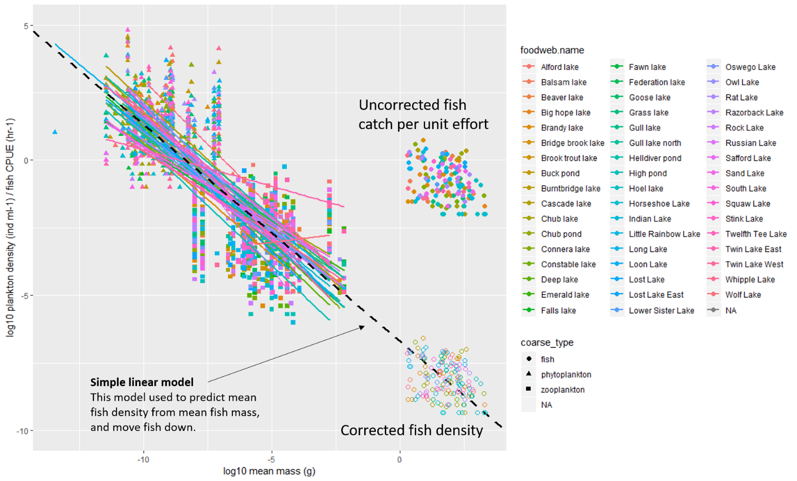

This relationship was also used to predict fish fry abundance.

